**BIPOLAR JUNCTION TRANSISTOR**

BJT also known as bipolar junction transistor as the name suggest it is a type of transistor which uses both electrons as well as the electron holes as charge carriers therefore it is called bipolar. It is a three pin device (emitter , base, collector). Now if we look towards its history at first the bipolar point contact transistor was invented by Jhon Bardeen and Walter Brattain in December 1947 at Bell Telephone Laboratories. Later the junction version which we are using today as BJT , invented by William Shockley in 1948.

Now looking at its types It is of two types :-

1. pnp BJT
2. npn BJT

**NPN Transistor**

An npn-transistor is composed of two n-type semiconductor materials which are separated by a thin layer of p-type semiconductor. A thin layer of p-type semiconductor sits between two n-type semiconductor components to form a npn transistor. Emitter and Collector, two terminals, are removed from two n-type semiconductors, while Base, a terminal, is removed from a p-type semiconductor.

The arrow in the BJT symbol points in the direction of the conventional current flowing through the emitter with forward bias. The conventional current exits the emitter of a npn transistor, as shown by the outgoing arrow.

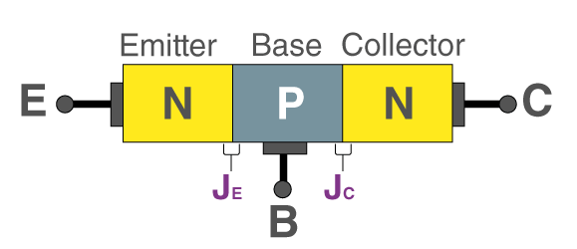

## PNP Transistor

Two p-type semiconductors are sandwiched between a thin layer of n-type material to form a pnp transistor. The base terminal is from the n-type semiconductor, and the two terminals, Emitter and Collector, are removed from the two p-type semiconductor layers. The usual current for thepnp transistor flows into the emitter as shown by the inwardarrow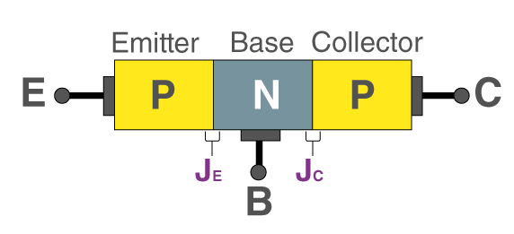

The main use of BJTs are it is widely used either as amplifier in analog devices and as switch in electronic devices.

**Circuit diagram of BJT:-**

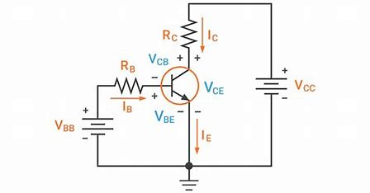

BJT is a semiconductor device that is constructed with 3 doped semiconductor Regions i.e. Base, Collector & Emitter separated by 2 p-n Junctions.

**Working of BJT:-**

Transistors are three terminal active devices made from different semiconductor materials that can act as either an insulator or a conductor by the application of a small signal voltage. The transistor’s ability to change between these two states enables it to have two basic functions: “switching” (digital electronics) or “amplification” (analogue electronics). Then bipolar transistors have the ability to operate within three different regions:

* Active Region   –   the transistor operates as an amplifier
* Saturation   –   the transistor is “Fully-ON” operating as a switch and Ic = I(saturation)
* Cut-off   –   the transistor is “Fully-OFF” operating as a switch and Ic = 0

## Bipolar Transistor Configurations:-

As the **Bipolar Transistor** is a three terminal device, there are basically three possible ways to connect it within an electronic circuit with one terminal being common to both the input and output signals. Each method of connection responding differently to its input signal within a circuit as the static characteristics of the transistor vary with each circuit arrangement.

* Common Base Configuration   –   has Voltage Gain but no Current Gain.
* Common Emitter Configuration   –   has both Current and Voltage Gain.
* Common Collector Configuration   –   has Current Gain but no Voltage Gain.

## Common Base (CB) Configuration

## In the Common Base or grounded base arrangement, as the name implies, the BASE connection is shared by the input signal AND the output signal. The base and emitter terminals of the transistor receive the input signal, and the base and collector terminals receive the matching output signal, as indicated. The base terminal can be linked to a fixed reference voltage point or is grounded.

## Common Emitter (CE) Configuration

The input signal is applied between the base and the emitter in the common emitter or grounded emitter configuration, and the output is obtained, as indicated, from between the collector and the emitter. This arrangement, which exemplifies the "normal" way to connect bipolar transistors, is the most popular circuit for transistor-based amplifiers.

## Common Collector (CC) Configuration

The collector terminal is shared by the input and output in the common collector or grounded collector configuration because the collector is linked to ground through the supply. The output signal is obtained as illustrated from across the emitter load resistor, while the input signal is linked directly to the base terminal. Common names for this kind of setup include voltage follower and emitter follower circuits.**haracteristic curve of BJT:-**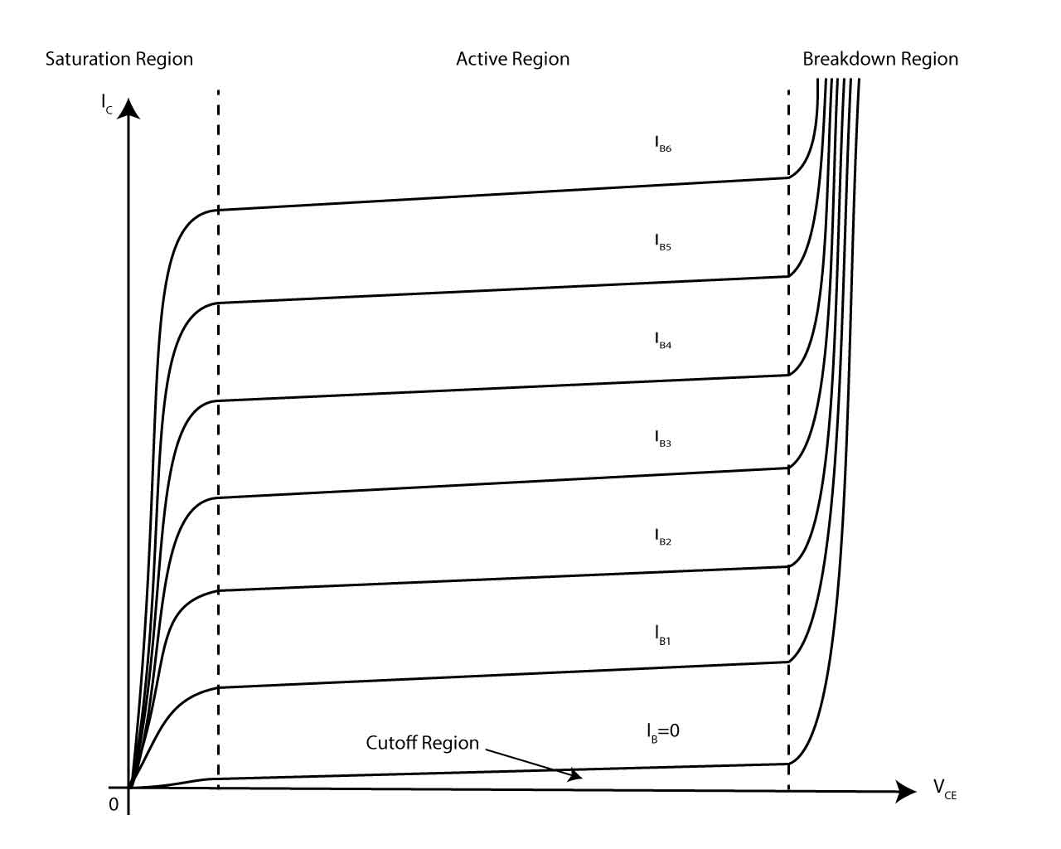

**Applications of BJT:-**

* Amplification: amplifying small input signals to larger output signals.
* Switching: turning electronic circuits on and off.
* Oscillation: generating periodic waveforms in oscillator circuits.
* Voltage regulation: stabilizing or regulating voltages in electronic circuits.
* Signal processing: converting signals from one form to another in electronic circuits.
* Digital logic: implementing logical functions in digital circuits.
* Radio frequency (RF) communication: amplifying and processing RF signals in wireless communication systems.

**GITHUB LINK:-**